Unite one

LIMIT AND CONTINUITY

**1.1 Definition of limit**

* 1. **.1 Intuitive (informal) definition of limit**

In this section, we are going to take an intuitive approach to limits and try to get a feel for what they are and what they can tell us about a function. With that goal in mind, we are not going to get into how we actually compute limits yet. The approaches that we are going to use in this section are designed to help us understand just what limits are.

Before defining the concept of limit, let us consider the following example which illustrates the concept of limit.

***Example:1***

Let the function f(x) be defined by

f(x) =  Study the behavior of the function near x = 1

**Solution**: -

We see that x cannot be equal to 1. What do you observe if x is near 1 either from the left or from the right? We can take the values of x near x = 1 in two different directions.

Let us take the values of x close to 1 from the right, and from the left, and study the behavior of the function from the following table.

|  |  |  |  |  |  |  |  |  |  |  |  |
| --- | --- | --- | --- | --- | --- | --- | --- | --- | --- | --- | --- |
| x gets closer & closer to 1 from the left | | | | | | x gets closer & closer to 1 from the right | | | | | |
| x | 0 | 0.5 | 0.9 | 0.99 | 0.999 | 1 | 1.0001 | 1.001 | 1.01 | 1.1 | 1.5 |
| f(x) | 0 | 1.5 | 2.7 | 2.97 | 2.997 | ? | 3.0001 | 3.001 | 3.01 | 3.1 | 3.5 |

Using the above table the graph of f is as shown by fig 1.1 bellow.

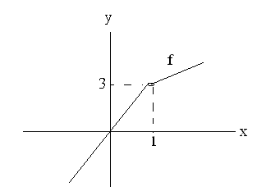

Fig 1.1

# From the above table and the graph we can observe that

* As x gets closer and closer to 1 both from the right and left, the corresponding values of f gets closer & closer to 3.
* f can be made to assume values near 3 if we take x sufficiently close to 1, but not necessarily equal to 1.

This fact can be expressed by saying that f(x) approaches 3 as x approaches 1 from either side. This saying is symbolically expressed as:

f(x) = 3

and is read as “the limit of f(x) as x approaches 1 is equal to 3. “

|  |
| --- |
| **Definition 1.1**.***Informal or intuitive definition of limit***.  Let f be a function and “c” some fixed real number such that f is defined for all x (except possibly at x = c) in some open interval containing c. If as x approaches c both from the left, and from the right, f(x) approaches a specific number L, then L is called the limit of  f( x) as x approaches c.  This is written as:  f(x) = L |

Whenever the values of x sufficiently close to c, but not necessarily equal to c (on both sides of c), the corresponding values of f(x) become arbitrarily close to L.

Referring to example 1 if x takes values closer, and loser to 1 both form right, and left, the corresponding values of f(x) get closer, and closer to the same real number.

**Activity 1.1**

* **Do you think that f(x) behave always the same way?**
* **And what does it mean precisely to say that, f(x) gets closer to L or x gets close to c?**

Let us try to answer these questions by considering the following example.

***Example2***. Let the function f(x) be defined by

f(x) = 

Study the behavior of the function near x = 1.

**Solution**:

The following table gives the values of x to the right & left of x = 1 respectively, and the corresponding values of f(x).

|  |  |  |  |  |  |  |  |  |  |  |  |  |  |
| --- | --- | --- | --- | --- | --- | --- | --- | --- | --- | --- | --- | --- | --- |
| x gets closer & closer to 1 from the left | | | | | | | x gets closer & closer to 1 from the right | | | | | | |
| x | 0 | 0.5 | 0.9 | 0.99 | 0.999 | 0.9999 | | 1 | 1.0001 | 11.001 | 1.01 | 1.1 | 1.5 |
| f(x) | -3 | -2.5 | -2.1 | -2.01 | -2.001 | -2.0001 | | ? | 3.0001 | 3.001 | 3.01 | 3.1 | 3.5 |

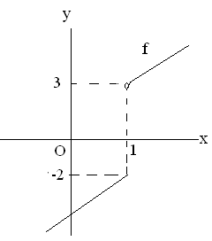

Fig.1.2

# From the above table, and the graph we can see that

* For values of x to the right of x =1 we take the function f(x) = x +2, and as x takes values close to 1 from the right, f(x) becomes close to 3.
* For values of x to the left of x = 1, we take the function f(x) =x –3, and as x takes close to 1 from the left, f(x) becomes close to –2.
* It is therefore obvious that f(x) can be made close to 3 or –2 if we take x sufficiently close to x = 1 by taking the values of x to the right or to the left of x = 1 respectively.

Thus, this fact can be expressed by saying that:

1. f(x) approaches 3 as x approaches 1 from the right. This is symbolically expressed as:

f(x) = 3

and is read as “the limit of f(x) as x approaches 1 from the right is equal to 3.” The number 3 is called the right hand limit of f(x).

1. f(x) approaches –2 as x approaches 1 from the left. This is symbolically expressed as:

 f(x) = -2

and is read as “ the limit of f(x) as x approaches 1 from the left is equal to –2.

The number –2 is called the left hand limit of f(x).

**1.1.2  Definition of limit**

***Definition :*** *Let f(x) be a function defined on an interval that contains x =a,*

*except possibly at x = a. Then we say that,*

$$\underset{x→a}{\begin{aligned} \\ lim\end{aligned}}{f\left(x\right)=L}$$

$∀ε >0 , ∃δ >0 such that \left|f\left(x\right)-L\right| <ε$*whenever $0<\left|x-a\right| <δ$*

Let’s take a look at the following graph

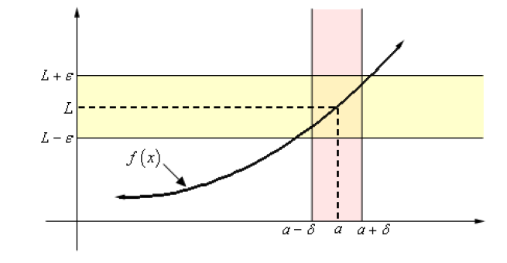

What the definition is telling us is that for **any** number ε > 0 that we pick we can go to our graph and sketch two horizontal lines at *L* +ε and *L* −ε as shown on the graph above. Then somewhere out there in the world is another number δ > 0 , which we will need to determine, that will allow us to add in two vertical lines to our graph at *a* +δ and *a* −δ .

Now, if we take any *x* in the pink region, *i.e.* between *a* +δ and *a* −δ , then this *x* will be closer to *a* than either of *a* +δ and *a* −δ . Or,

$$\left|x-a\right|< δ$$

If we now identify the point on the graph that our choice of *x* gives then this point on the graph

**will** lie in the intersection of the pink and yellow region. This means that this function value *f(x)*

will be closer to *L* than either of *L* +ε and *L* −ε . Or,

$$\left|f(x)-L\right|< ε$$

So, if we take any value of *x* in the pink region then the graph for those values of *x* will lie in the

yellow region.

***Example 1*** Use the definition of the limit to prove the following limit.

$$\lim_{x→0}{x^{2}=0}$$

**Solution**

In this case both *L* and *a* are zero. So, let ε > 0 be any number. Don’t worry about what the number is, **ε** is just some arbitrary number. Now according to the definition of the limit, if this

limit is to be true we will need to find some other number δ > 0 so that the following will be

true.

$\left|x^{2}-0\right| < ε$ whenever $0<\left|x-0\right| < δ$

$\left|x^{2}\right| < ε$ whenever $0<\left|x\right| < δ$

$→ {\left|x\right|}^{2}$ $< ε$

= $\left|x\right| < \sqrt{ε}$

Now, the results of this simplification looks an awful lot like $0<\left|x\right| < δ$ with the exception of

the “ 0 < ” part

So, it looks like if we **choose δ = $\sqrt{ε}$**  we get what we want.

We’ll next need to verify that our choice of **δ** will give us what we want,

$\left|x^{2}\right| < ε$ whenever $0<\left|x\right| < δ$ = $\sqrt{ε}$

Once this is done we’ll use our assumption on *x*, namely that $\left|x\right| <$ $\sqrt{ε}$

$\left|x^{2}\right| ={\left|x\right|}^{2} <{(\sqrt{ε})}^{2}$ from the assumption $\left|x\right| <$ $\sqrt{ε}$

**= $ε$**  Done!

We’ve shown that if we choose ε > 0 then we can find a δ > 0 so that we have,

$\left|x^{2}-0\right| < ε$ whenever $0<\left|x-0\right| < δ$ = $\sqrt{ε}$

and according to our definition this means that,

$$\lim_{x→0}{x^{2}=0}$$

***Example 2 :*** Use the definition of the limit to prove the following limit

$$\lim_{x→2}{5x-4=6}$$

***Solution***

$let ∀ε >0, ∃ δ >0$ such that

$\left|(5x-4)-6\right| < ε$ whenever $0<\left|x-2\right| < δ$

We’ll start by simplifying the left inequality in an attempt to get a guess for δ

So,

$$\left|(5x-4)-6\right| =\left|5x-10\right|=5\left|x-2\right| < ε$$

⇒ $\left|x-2\right| < \frac{ε}{5}$

Now. simplification on the left inequality we get something that looks an awful lot like the right inequality and this leads us to **choose δ = $\frac{ε}{5}$**

We’ll next need to **verify** that our choice of **δ** will give us what we want,

$0<\left|x-2\right| < δ$ = $\frac{ε}{5}$ and we get the following

$$\left|\left(5x-4\right)-6\right| =\left|5x-10\right|$$

$$=5\left|x-2\right|$$

< 5( $\frac{ε}{5})$**since $\left|x-2\right|$**  < $δ$ = $\frac{ε}{5}$

**= $ε$**  Done!

So, we’ve shown that

$\left|\left(5x-4\right)-6\right| < ε$ whenever $0<\left|x-2\right| < δ= \frac{ε}{5}$

**Hence,**  by our definition we have $$\lim_{x→2}{5x-4=6}$$

|  |
| --- |
| **Definition: (Right hand limit)**  Suppose the domain of a function f contains an open interval (c, b). For number ‘c’ and ‘L’ we say that the right hand limit of f(x) as x approaches c is L, written as  f(x) = L  If and only if , for all values of x close to ‘ c’ from the right of x = c but not necessarily equal to c, the corresponding values of f(x) become arbitrarily close to the number L. |

|  |
| --- |
| **Definition**: **(Left hand limit)**  Suppose the domain of a function f contains an open interval (a, c). For numbers ‘c’ and ‘ L ‘ , we say that the left hand limit of f(x) as x approaches c is L , written as:  f(x) = L  If and only if, for all values of x close to c from the left of x = c, but not necessarily equal to ‘ c’ , the corresponding values of f(x) become arbitrarily close to the number L. |

let’s give the precise definitions for the right- and left-handed limits

**Definition (right hand limit)**

For the **right hand limit** we say that , $$\underset{x→a^{+}}{\begin{aligned} \\ lim\end{aligned}}{f\left(x\right)=L}$$

$∀ε >0 , ∃δ >0 such that \left|f\left(x\right)-L\right| <ε$*whenever $0<x-a<δ (or a<x<a+δ$)*

**Definition (left hand limit)**

For the **left hand limit** we say that , $$\underset{x→a^{-}}{\begin{aligned} \\ lim\end{aligned}}{f\left(x\right)=L}$$

$∀ε >0 , ∃δ >0 such that \left|f\left(x\right)-L\right| <ε$*whenever $-δ<x-a<0 (or a-δ<x<a$)*

When we combine the above two definitions we get the following

|  |
| --- |
| **Definition 1.4**: **(Two sided limit)**  Suppose f is a function & c is a fixed real number. A real number L is called the limit of f at c, if and only if the left and right hand limits exists and are equal to L. That is  f(x) = f(x) =L |

In other words, f(x) = L if and only if both of the following hold.

1. f(x) and  f(x) are equal numbers , and
2.  f(x) = L = f(x)

Note the following forms that provide alternatives about limits of a function f at x = c.

* If  f(x) = L , then f(x) = L and f(x) = L
* If  f(x) = f(x), then  f(x) = L
* If  f(x) ≠ f(x), then  f(x) does not exist.

**Note:** If the limit of a function f as x approaches some number c exists, then the limit is unique. That is:-

If  f(x) = L, and  f(x) = M, then L = M

Do you see that in the last example,

 f(x) =  (x +2) =3,

but f(x) =  ( x-3) = -2

This implies that  f(x) ≠  f(x). (Why?)

Hence,  f(x) does not exist.

## **Examples 1:** Study the behavior of the function , near x = 3.

**Solution**:

If we factorize x2-5x +6, we get x2- 5x +6 = (x –3) (x – 2).

Therefore, f(x) = x2- 5x +6 = ( x –3) (x – 2)

x – 3 x – 3

Here the domain of f(x) is the set of all real numbers except x =3

Therefore,

 for x ≠ 3

Now, draw the graph of f.

### 

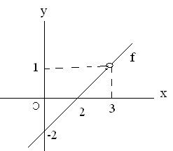

Fig 1.3

We are interested in the behavior of f as x approaches 3, but not necessarily equal to 3.

(Why?)

From the graph of f (fig 2.3), we can observe that f(x) =f(x) = 1.

Hence, f(x) = 1

**Example 2:** Study the behavior of the function f(x) = when x is sufficiently closer to 5.

**Solution**:

The domain of this function is the set of all real numbers greater than or equal 5. Therefore, we can take any value for x to the left of x = 5. This leads us to the conclusion

 does not exist.

On the other hand, as x gets closer to 5 from the right of x = 5, (x –5) gets closer to 0. This leads to the conclusion 

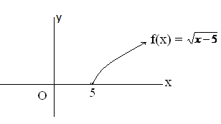Fig 2.4

# Hence, does not exist. (**Why?**)

As a result, does not exist.

# **Exercise 2.1**

1. Find the limits (two sided, right or left) of the following functions if they exist at c by drawing the graph.

, c=1 , c=2

 , c=3

2. Given the following graph,

Fig2.5

Compute each of the following.

**a)** *f* (-4) b.  c.  d. 

e. *f* (1) f.  g.  h. 

* 1. **Limits of elementary functions**

1. **Limit of a constant function.**

If f(x) = k, where k is any constant number, then

f(x) =  k = k for any cR

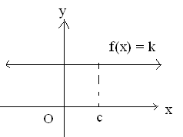

Fig 2.6

From the above graph we observe that the graph of f is a horizontal line thus no matter what value of x,f(x) is always constant k.

2. **Limit of linear function.**

If f(x) = x, then for cIR, f(x) =  x = c

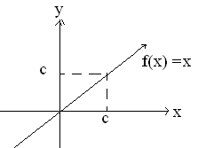

Fig 2.7

**3. Limit of a power function.**

For cIR, and n  N, if, then  f(x) =  xn = cn

For the sake of simplicity let us consider the case when n = 2, & c = 2

Let  is defined for all x and its graph is a parabola. Hence, for all values of x close to 2 from either side (right or left), f(x) approaches the value 4.

That is,  f(x) = x2 = 4.

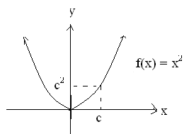

Fig 2.8

4. **Limit of square root function**

For c > 0, if f(x) =  then  f(x) =  = 

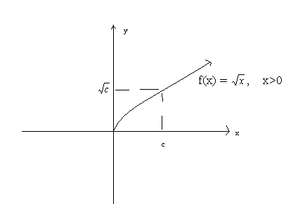

Fig.2.9

5. **Limit of Exponential function**

For c ∈ R, a > 0, and a #1 , if f (x) = ax then f(x) =  ax = a c

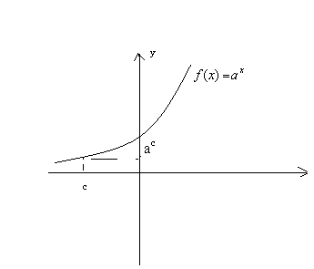

Fig2.10

6. **Limit of trigonometric functions**

a. For c∈, if f(x) = cos x, then  f(x) = cos x = cos*c*. Since f is defined for all values of x.

b. For c∈, if f(x) = sin x, then  f(x) = sinx = sinc. Since f is defined for all values of x.

7. **Limit of logarithmic function**

For x > 0, a > 0, a≠ o, if f(x) = logax then  f(x) = logax = logac

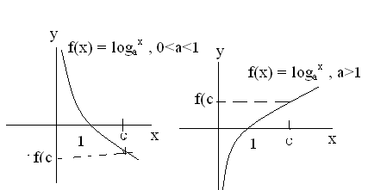

Fig 2.11

8. **Limit of absolute value function**

For c∈, if f(x) = | x|, then  f(x) = |x | = |c |. Since f is defined for all values of x.

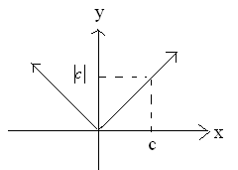

Fig 2.12

**Exercise 2.2**

1. For the graphs of the functions given below fig. 2.13a to fig. 2.13c find:

a.  b.  c. 

if they exist.

Fig 2.13a Fig 2.13b 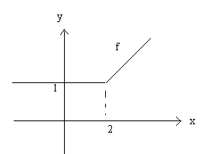 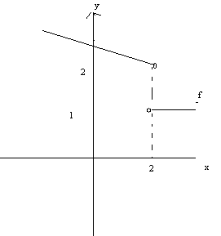

Fig 2.13c

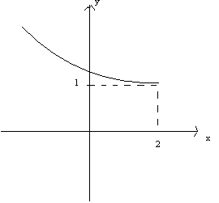

In questions, 2-12, determine wether the following limits exist or not, and find the limit whenever it exists by drawing the graph.

a.  f(x) b.  f(x) c.  f(x)

2. f(x) = 3x −1 ; c = 1/3 3. f(x) = x2 −1 ; c = −1

x +1

4. f(x) =  c = − 2 5. f(x) = cosx ; c =  6. f(x) = 4x ; c = 0 7.  8. 

9. f(x) = sin x; c = 0 10. 

11. f(x) = | x | ; c = 0 12. f(x) = log5x ; c = 1/5

x

13. f(x) =  

**1.3 Limit theorems (Properties)**

In this section, we will evaluate or compute limit of a function at a point using the following basic properties of limit. The justification of these theorems will be given in another course.

|  |  |
| --- | --- |
| **Theorem 1.1**  Suppose c, k, L, M,  . If  f(x) = L and g(x) = M , then  1.  k f(x) = k  f(x) = kL ( constant multiple rule)  2.  f(x)+g(x) =  f(x) +  g(x) = L+M (addition rule)  3. (f(x) -g( x)) = f(x) − g (x) = L−M (difference rule)  4.  [f (x) g (x) ] =  f(x).g(x) =LM (Product rule)  5.  =  =, provided M≠ 0 (Quotient rule)  6. [ f(x) ]n = [  f(x)] n = Ln , n  ,Ln R ( Power rule) | |
| **Note:**  i. The result of theorem 2.1 can be extended to a finite number of functions.  ii. Theorem 2.1 is valid if c is replaced by positive infinite or negative infinite. |

**Examples 1:** Evaluate  (x2 + 4)

**Solution:** We will use only the properties above to compute the limit. First we will use property **2** to break up the limit into two separate limits. We will then use property **3** to break x2 as the product of x and x.

This gives us,

 (x2 +4) =  x2  +  4 Addition rule

=  x. x +4 Product Rule

= c. c +4

= c2 + 4

**Examples 2:** Evaluate 

**Solution**:

Applying all rules in theorem 2.1 we have:

 =  Quotient rule

=  Addition and Difference rule

= $\frac{3(1) + 6}{5(1) + 4 (1)-2}$

= $\frac{9}{7}$

**Example 3**: Evaluate 

###### **Solution:**

###### = cos x +kx Addition Rule

 =cos x + k  x Product Rule

= cos+ k ()

=+k

= 

**Example 4**: Evaluate 

**Solution:**

=  Addition Rule

=  Constant Multiplication Rule

= 4(3)2 + 5(3) +3

= 36 + 15 + 3

= 54

###### Therefore, =

=  = 

**Example 5**: Evaluate 

**Solution:**

= +  Difference Rule

= − 3 Constant Multiple Rule

=2(−1) −3

= −5

Therefore, = []4 Power Rule

= ( −5)4 = 625

**Example 6**: Evaluate 

**Solution:**

  Addition Rule

= −3 + 2 = −1

Therefore,  = 

since  is not a real number. Hence,   does not exist.

**Activity 1.2**

Show the following limits

a) If P is ;8a polynomial function of degree n, then P (x) = P (c)

b) If r is a rational function of the form r (x) = f(x), where

g(x)

f(x) & g(x) are polynomial functions of degree n, & m respectively , & g(x)  0, then

 r(x) =  = = r( c), g ( c )  0

|  |
| --- |
| **Theorem 2.2**. **(Squeeze theorem )** Suppose c is a constant.  If f(x) = L, g (x) = M and f(x) < g(x) for all x, then L < M and also if the function h(x) is given by f(x) < h(x) <g(x) and if L = M , then h (x) = L |

The following figure illustrates what is happening in this theorem.

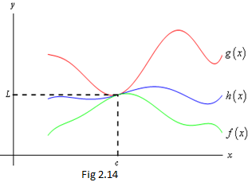

From the figure we can see that if the limits of *f(x)* and *g(x)* are equal at *x=c* then the function values must also be equal at *x* =*c.* However, because *h(x)* is “squeezed” between *f(x)* and *g(x)* at this point then *h(x)* must have the same value.

Therefore, the limit of *h(x)* at this point must also be the same

**Note**: Theorem 2.2 is valid if c is replaced by positive infinity or negative infinity.

**Example1:** Evaluate  x sin ()

**Solution:** Form Trigonometry we know that the range of sine function is [-1, 1]

i.e. −1 < sin  ≤ 1, for all x  0

Then if we multiply the inequality by x for x>0 and x<0 the result is the same for two cases:

-x ≤ xsin ≤ x, for x>0, & −x > xsin  ≥ x, for x < 0

But since  (-x ) = 0 , &  x =0

That is, (-x) = 0 =  x

Therefore,  x sin  = 0. (Why?)

**Exercises 2.3**

1. Evaluate the following limits, if they exist.

|  |  |
| --- | --- |
| b)    c) | d)    e)  f) |
| g)  h)  ( x3 +  x −5 )4  i) | j)  k)  l) |

**2.4 Limit at infinity**

In the previous sections, we have learnt how to find the limit of a function when the variable x approaches or tends to a definite constant real number c.

Now, here we are going to study the behavior of a function f as the value of x increases (decreases) infinitely. That is, x approaches positive infinity (or negative infinity), & this can be written as follows:

|  |
| --- |
| **Definition 5. Limit at infinity**  Let L be a real number. We say  f(x) =L if and only if when x approaches sufficiently very large positive ( or small negative) values, the corresponding value of the function of approaches the number L. |

**Example1.** Study the behavior of the function.



**Solution:** To have clear idea, let us have table of values of f for some values of x.

|  |  |  |  |  |  |  |  |  |  |  |
| --- | --- | --- | --- | --- | --- | --- | --- | --- | --- | --- |
| x gets smaller & smaller x gets larger & larger | | | | | | | | | | |
| X | −99998 | -9998 | -998 | -98 | -8 | 12 | 102 | 1002 | 10002 | 100002 |
| f(x) | -0.00001 | -.0001 | -0.001 | -0.01 | -0.1 | 0.1 | 0.01 | 0.001 | 0.0001 | 0.00001 |

From the table we observe that

* As x gets very large without bound, the corresponding values of f gets closer & closer to 0.

We express this as:



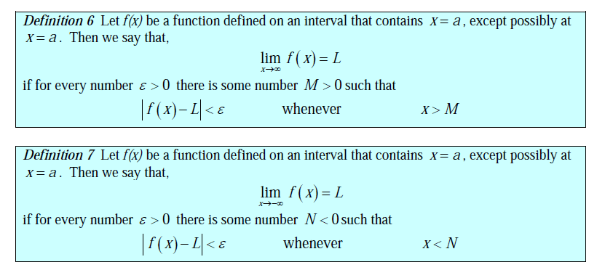

**Example 1:** Use the definition prove the limit of ,

1. 

**Solution**

Let for every ɛ > 0 there exist some number M > 0 such that

|f(x)-L|< ɛ whenever x > M

⇒ whenever 

⇒

Choose M = 

Next Let’s verify that our choice M =  ,

= 

⇒

⇒ take the absolute value

 done!

Therefore , by the definition



**Solution**

Let for every ɛ > 0 there exist some number N > 0 such that

|f(x)-L|< ɛ whenever x < N

⇒ whenever 

⇒

Choose N = -

Next Let’s verify that our choice N = - ,

= -

⇒

⇒ take the absolute value

 done!

Therefore , by the definition



**Activity 2.3**

Study the behavior of the function f defined by: f(x) =  when x tends to infinity.

**2.5 Infinite limits**

In this section, we will take a look at limits whose value is infinity or minus infinity. These kinds of limit will show up fairly regularly in later sections and in other courses and so you’ll need to be able to deal with them when you run across them.

Let us illustrate this concept using example.

**Example1:** Study the behavior of the functions f(x) =  near x = 2

**Solution:** Let us use table of values of f for some values of x near x = 2

Here is a table of values of *x*’s from both the left and the right. Using these values we’ll be able to estimate the value of the two one-sided limits.

|  |  |  |  |  |  |  |  |  |  |  |  |
| --- | --- | --- | --- | --- | --- | --- | --- | --- | --- | --- | --- |
| x gets closer and closer to2 from the left x gets closer & closer to 2 from the right | | | | | | | | | | | |
| X | 1 | 1.5 | 1.9 | 1.99 | 1.999 | 1.9999 | 2 | 2.0001 | 2.001 | 2.01 | 2.1 |
| f(x) | -1 | -2 | -10 | -100 | -1000 | -10000 | ? | 10,000 | 1,000 | 100 | 10 |

From the table, we can observe that as x approaches 2 from the right of x = 2, the corresponding values of f(x) are positive, and get larger, and larger without bound. Also as x approaches 2 from the left of x =2, the corresponding values of f(x) are negative , and get smaller and smaller without bound.

Symbolically these facts are expressed as;

i) 

ii) 

Do you see that f(x) =  has neither a finite nor an infinite two sided limit at x = 2?

|  |
| --- |
| **Definition**: Let c be a real number. We say that a function f has an infinite limit at c, and write  lim f(x) = ∞ or lim f(x) = −∞  x →c x →c  If for an all values close to ‘c’ but not necessarily equal to ‘c’ both from the right, and from the left, the corresponding value of f(x) becomes a very large number positively or very small negatively. |

**Exercises 2.4**

Evaluate the limits of the following functions.

1.  2. 

3.  4. 

5.  6. . 

7.  8. 

9. 

**Formal definition (an infinite limit)**

Let f(x) be a function defined on an interval that contains x = a, except possibly at x = a. Then we say that ,



If for every number M > 0 , there is some number $δ$ >0 such that

f(x) > M whenever 0< |x – a| <

Let f(x) be a function defined on an interval that contains x = a, except possibly at x = a. Then we say that ,



If for every number N < 0 , there is some number $δ$ >0 such that

f(x) < N whenever 0< |x – a| <

**Example 1:** Use the definition of the limit to prove the following limit



**Solution**

for every number M > 0 , there is some number $δ$ >0 such that f(x) > M whenever 0< |x – a| <

so,  whenever 0< |x – 0| = |x| <

⇒

⇒ =  from the fact of 

So choose $δ=$

Next we need to verify

|x| < = 

⇒|x| < 

⇒ square both sides

 = 

Therefore , by the definition of the limit 

**1.6 Computing Limits**

In the previous examples, we have seen functions which have limits, and which do not have limits at a point. Particularly some functions have limits at a point which coincide with the values of the function at that point. But finding a limit is not always a direct substitution. Here we will learn some techniques of finding the limit of a function with the help of examples.

**Example1.** Evaluate 

**Solution:**

First let’s notice that if we try to substitute in *x* = -2 we get



So, we can’t just substitute in *x= -*2 to evaluate the limit. So, we’re going to have to do something else.

The first thing that we should always do when evaluating limits is to simplify the function as much as possible. In this case, that means factoring both the numerator and denominator. Doing this gives



= 

So, upon factoring we saw that we could cancel an *x+*2 from both the numerator and the denominator. Upon doing this, we now have a new rational expression that we can substitute *x* = -2 into because we lost the division by zero problems. Therefore, the limit is

= -2+1= -1

**Example4**. Evaluate 

**Solution:**

Once again, however, note that we get the  if we try to just evaluate the limit at x = 3 which is meaningless.

Let’s try rationalizing the numerator in this case that will help us in finding the limit.



= 

=

So, upon simplifying we saw that we could cancel an *x* - 3 from both the numerator and the denominator. That gives

= 

Now at this point the division by zero problems will go away and we can evaluate the limit.

= 

**Example 5:**  Evaluate 

***Solution:***

Observe that as x → ∞ , 6x +1 → ∞ and x +2 → ∞ . As a result, we get the ratio  which is undetermined.

We divide the numerator & the denominator by the highest power of x in the denominator, in this example x.

That is,



= 

= =

**Example 6.**

Evaluate 

Solution:  = 

**Example 7**



Evaluate a,  

**Solution :** firstthe first step factor out x from the numerator and the denominator, so we get

 =  since  = |x| =

Here we are considering two cases

**Case one : x is positive**

=  =  since *x* will be positive

=  =  = 

**Case one : x is negative**

=  =  since *x* will be negative

=  =  = 

**Exercise 2.5**

Evaluate the following limits if they exist.

|  |  |
| --- | --- |
| 1. lim ( )   x → 0  x → ∞  2. lim  x → -2  x → ∞  3. lim (-3- )  x → ∞  4. lim  + 4x –1  x → 4  x → -2  5. lim  x → ∞   1. lim x   x → 9 | 7. lim  8. lim  9. lim  10. lim  x → 0 |

**2.7 Asymptotes**

In the previous course (math 102) we studied that asymptotes are important elements in sketching graphs of rational functions.

Here we are going to study the application of limit in finding asymptotes of a given function which are useful in drawing graphs of these functions. Asymptotes are defined with respect to limits at infinity and infinite limits as follows:

|  |
| --- |
| **Definition 2.7** a. **(Vertical asymptotes)**  Let f be a function. For c∈ℜ, if lim f(x) = ∞ or lim f(x) = − ∞  x → c+ x → c+  or  lim f(x) = ∞ or lim f(x) = −∞  x → c- x → c-  then the line x = c is called a vertical asymptote to the graph of f. |

|  |
| --- |
| **Definition 2.7 b** **(Horizontal asymptote)**  For a real number L, if f(x) = L or f(x) = L, then the line y = L is called a horizontal asymptote of the graph of a function f. |

|  |
| --- |
| **Definition 2.7c (Oblique asymptote)**  For two real numbers a, b, & a ≠ 0 if,  [ f(x) - ( ax +b ) ]= 0 or  [ f(x) − ( ax +b) ] = 0 , then  the line y = ax + b is called an oblique asymptote of the graph of f |

**Example1**. Find the asymptote of the function, f(x) = 

**Solution:**

1. First we determine a vertical asymptote by considering the limit of f(x) as x approaches –3 from both sides since f(-3) is not defined.

That is,

  = ∞ and 

⇒ is vertical asymptote of f

b. Now determine a horizontal asymptote

To find the horizontal asymptote, find  and 

i.e.  and 

Therefore, y = 0 is the equation of a horizontal asymptote of the graph of f.

**Example2.** Determine the equation of the asymptotes of the function f(x) = , and sketch its graph.

**Solution:**

1. Since f(x) is not defined at x = ± 1, hence we have



 

 

 

Therefore, x = 1 & x = −1 are equations of the vertical asymptotes

b) In this case, when each term is divided by the highest power, the result is:

 = 

=  = 1

And similarly, 

Hence, y = 1 is a horizontal asymptote.

In order to sketch the graph of a function we have to find the intercepts.

Note that:

1. The function has no x –intercept (**Why?**)
2. y intercept is -1.

Therefore, the graph is given below in fig 2.16

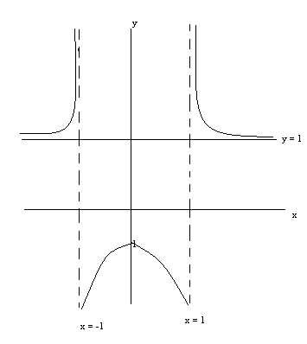Fig 2.16

**Example 3**: Find the asymptotes of the function f(x) =  , and sketch its graph.

**Solution**:

1. f is not defined at x = -3.

Hence,  & 

Hence, x = − 3 is a vertical asymptote.

1. By long division method we have:

f(x) =  = ( x − 3 ) +  ⇒ f(x) - ( x - 3 ) = 

Let a x +b = x – 3 then

Lim f(x) - (x -3) = lim  = 0

x 

And similarly,  f(x) - (x -3 ) =   = 0

Therefore, y = x − 3 is the oblique asymptote.

Again note that f has no, x-intercept, & its y- intercept is 1.

Hence the graph of f is the one given in fig 2.17

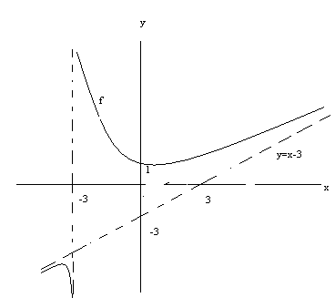

Fig 2.17

**Exercise 2.6**

1. Find the asymptotes of the graphs of the following functions and sketch the graph.

(a ) f (x = 

* 1. f(x) = 
  2. f(x) = 
  3. f (x) = 
  4. f(x) = 

**2.8 The two important limits**

In this section, we will learn how to find, &  .  The results of these limits help us to study limit of exponential, logarithmic & trigonometric functions.

|  |
| --- |
| **Theorem 2.3:** |

**Proof**: None of the techniques so far developed will help to find. So, to prove this theorem consider the following figure.

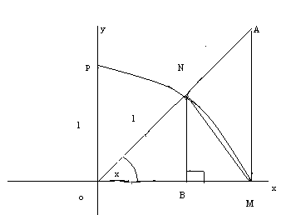

Fig 2.18

From the figure we see that

* PNM is an arc of a unit circle
* 00 < x < 900
* sinx = BN ( Why? )
* tan x = AM ( Why?)

Area of Δ ONM = ½ OM. BN = ½ sinx ………………….(1)

Area of sector ONM = πr2x = πrx

2πr 2π

= ……………………………….(2)

Area of Δ OAM = ½ OM .AM

= ½. AM

= ………………………………….(3)

Comparing the areas (1, 2 and 3) of the three regions, we get the following relations.

a (Δ ONM ) < a ( sector ONM) < (Δ OAM)

⇒ sin x < x < tanx

2 2 2

⇒ sin x < x < tanx (*)

⇒ 1 > 1 > cosx

sin x x Sinx

Since 00 < x <900, sinx > 0. Hence, multiplying (*) by sinx, we get:

1 > sinx > cos x

x

or

cosx < sinx < 1

x

Thus, 

⇒ 

⇒ = 1 (**Why?**)

For x>0 , sin (-x) = sinx (**why ?**)

−x x

Hence,, x ≠ 0 .

**Example1**: Evaluate 

**Solution:**

Using trigonometric identity, we have:

Cosx =Cos ( x + x )

2 2

= cos2 x − sin2x

2 2

=  , since 

= 1− 2 sin2 x

2

Therefore, 1 – cos x =1 – (1-2 sin2 x)

2

= 2 sin2x

2

 = 

=

=.0 = 1.0 =0

**Example 2**: Evaluate 

**Solution:**

 , x≠0 dividing both *sinx* and *sin5x* by *x*

= 

 

=

=

= =  = 

|  |
| --- |
| **Theorem 2.4:**  , where e ≈ 2.7182---, and e is an irrational number. |

The proof of this theorem is beyond the scope of this course. Hence, we shall accept it without proof, & use the information in the following discussions.

**Example 3**: Prove that 

**Proof**: We prove  by showing 

Let x = 1/t , then t = 1/x and as x→ 0 , t→ ∞

Hence, 

And similarly   since both the right and left limit exist and equal

Therefore, 

**Example 4**: Evaluate 

**Solution**:

 =  ………… Exponent rule

= ……….Product rules of limit

=

**Example 5**: Evaluate 

**Solution**:

Let t = 3/x. Then x= 3/t as x → ∞ ,t → o+

Hence,  = 

= 

= e3

**Example 6**: Evaluate 

**Solution**:

By long division method,  = 

Then  = 

Let t =  , Then x = . As x → ∞ , t → 0+

Hence, 

= 

= 

= e8 . 12

= e8

**Exercise 2.8**

Evaluate the following limits

1.  2.  3. and 

4.  and  5.   6. 

7.  8.  9. 

10. m ∈ℜ ∧ m≠ 0

**1.5 Continuity**

**1.5.1 Continuity of functions.**

In this section, we are going to deal with the definition of continuity of a function at a point from the point of view of a limit.

|  |
| --- |
| **Definition 1.8** The function f is said to be continuous at point c in its domain if .  In other words, f is continuous at a point c if  1. is defined  2. exist , and  3. |

If one of the three above conditions is not satisfied, then we say that f is not continuous at c.

For a better understanding of the above definition, let us first consider the graphs of the following functions.

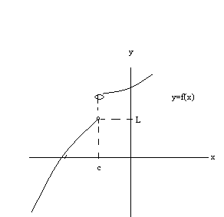 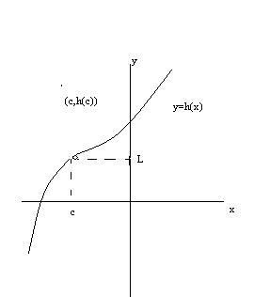

Fig 2.19a Fig 2.19b

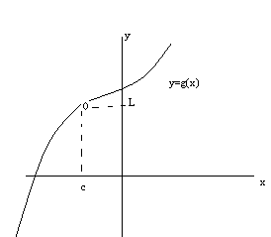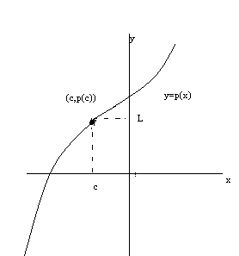

Fig 2.19c Fig 2.19d

From the above graphs, we observe that:

* Lim f(x) does not exist (why?)

x→c

* Lim g (x) = L, but g (c) is not defined.

x→c

* Lim h(x) = L, but lim h (x) ≠ h( c )

x→c x→c

* Lim P(x) = L, and lim P(x) = p( c )

x→c x→c

? In which of the above four cases the definition of continuity is satisfied?

|  |
| --- |
| **Note:** A function f is continuous at c in its domain if it has no “break “, “jump” or “hole“ in its graph. |

**Example 1**: Let f(x) =  , then determine whether f is continuous or not at x = -3 .

**Solution:**

When we substitute -3 for x in the function, we get f (-3) =  which is undefined. So f is failed to satisfy the first criteria of continuity and hence f is discontinuous (not continuous) at x = −3.

**Example 2**: Determine whether **is continuous at x =2 or not.

Solution: When we sketch the graph it looks like as follows:

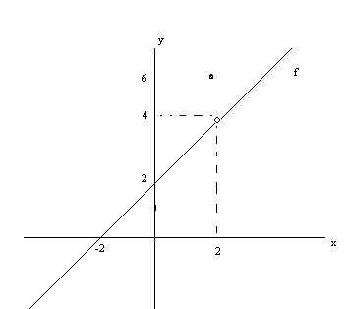Fig 2.20

Note that

1. f (2) = 6 which is defined
2.  the limit also exists
3. But since , hence f is not continuous at x = 2

**Example 3**: Determine whether f (x) = 5x + 1 is continuous at x = 0 or not.

**Solution**:

Here we have to check three conditions by definition whether f is continuous or not.

1. f (0) = 5 (0) + 1 = 1, which is defined
2. lim f( x) = lim ( 5x +1) = 1, the limit also exist

x→0 x→0

1. And hence, lim f(x) =1= f (0).

x→ 0

Therefore, f is continuous at x = 0

**Example 4**: Determine the number at which  is continuous.

**Solution:**

Since the denominator x2 − 25 = 0 for x = − 5 & x = 5, hence f(x) is defined for all x except −5, and 5.

Therefore, f is continuous at every number except −5 and 5.

**Example 5**: Determine whether f(x) = 3, if x >= 2

−3, if x < 2 , is continuous at x = 2 or not.

**Solution:**

Note that

1. f(2 ) = 3 , which is defined
2. But does not exist (**why**?)

Hence, f is not continuous at x = 2

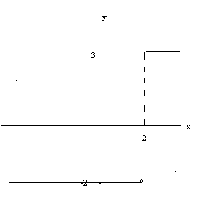Fig 2.21

|  |
| --- |
| **Theorem 1.5**: Suppose f, and g are with the same domain such that both f and g are continuous at x = c then,   1. k f is continuous at x = c, for k 2. f +g, is continuous at x = c 3. f -g is continuous at x = c. 4. f.g is continuous at x = c 5. f/g is continuous at x = c, provided that of g( c ) ≠o |

Proof: ii) Since f and g are continuous at x = c, hence we have

Lim f(x) = f (c) and Lim g (x) = g (c)

x→ c x→ c

Then using sum rule for limit, we have:

Lim [ f (x) + g (x ) ] = lim f( x ) + lim g( x)

x→ c x→ c x→ c

= f(c) + g (c)

= (f + g) ( c )

Therefore, f+g is also continuous.

Similarly we can prove the remaining parts.

**Example 6:** Let  what value of a makes f continuous at x=-1?

**Solution:** In order for  to be continuous at x=-1, **

Since  and , we must guarantee that .

Since  is a polynomial function, we can substitute -1 for x and solve the resulting equation, 

|  |
| --- |
| Note: 1) Every polynomial function is continuous on ( − ∞ , ∞) .(Why?)  2) Every rational function is continuous on ( − ∞ , ∞) except at points where  its denominator is zero. (Why?) |

|  |
| --- |
| **Theorem 2.6**  **(Substitution rule )**  If g is continuous at x = c, and f is continuous at g (c), then f [g (x)] is continuous at x=c.  That is ,  **=** |

**Example 7:** Evaluate 

**Solution:** Let and g(x) = 4x. Then, since

 and  is continuous at x = 2.

Hence, by substitution rule,



**Example 8**: Evaluate 

**Solution:** Let f(x) =  and. Since  and  is continuous at x = 3, hence, by substitution rule,



**Example 9:** Evaluate 

**Solution : $f\left(x\right)= e^{x}$** and $g\left(x\right)= sinx$

$e^{\lim_{x→0}{sinx}}$ = $e^{0}$ = 1 (since sine function is continuous everywhere

**Exercise 2.7**

1. Determine the points at which the following functions are discontinuous.

a) f ( x) = x4 − 5x3 + − x2 + 1 b) f (x) = 

1. f( x) = x3 +1

x2 − 6

d) f ( x) =  if x > 0 e. f (x) = sec x; x  [ 0, ]

−2 if x <0

1. Find the value of a such that f is continuous at the given point.

a) f(x) = ax + 1 if x ≥ 4

3ax-7 if x < 4 , at x = 4

b) f (x) = 

**1.5.2 One sided continuity of a function**

In our forgoing discussions we have seen that  = 0, but  does not exist. Hence by definition of continuous function, the function f given by

f(x) = is not continuous at x = 5. But . This shows f is continuous from the right side of 5.

|  |
| --- |
| **Definition 1.9 ( One-sided continuity)**  i) A function f is continuous from the right ( right-continuous) at x = c in its domain if  1. *is defined*  2. *exist , and*  3*.*  ii) f is continuous from the left at c if the corresponding statements are true with  replaced by. |

From the above definition, we observe that f is continuous at x = c in its domain if and only if f is both right and left continuous at c.

**Example9.** Determine the continuity of the function f defined by

f(x) =  at x = 1.

**Solution:** Since  f(x) =  2 = 2 and f (1) = 2, hence, f is continuous from the right at x = 1.

But since  and f (1) = 2 ≠ , hence, f is not continuous from the left at x =1.

Therefore, f is not continuous at x = 1 (**why?**)

|  |
| --- |
| **Definition 1.10.** **( Continuity on intervals)**  The function f is continuous on [a, b] if f is continuous on (a, b), f is continuous from right at a, and f is continuous from the left at b. |

|  |
| --- |
| **Note**: A function f is said to be continuous, if it is continuous at each point in its domain. Similarly, we can define the continuity of functions on half–open, & half-closed intervals. |

**Example10.** Determine the continuity of  on the interval **[-2** , 2].

**Solution:** The domain of the function f is [-2, 2]. Here we have to show three things.

1.  and .

Since, hence f is continuous from the right at x = -2.

1. Again since,  & .

Hence  which means f is continuous from the left at x = 2.

1. And also , let c ∈ ( −2, 2 ) then f(x) =   = = f ( c)

Hence, f is continuous at each point in ( -2, 2).

Therefore, f is continuous on [-2, 2].

**Exercise 2.8**

1. Determine whether f is continuous from the left or from the right or continuous at x = c
   1. f(x) =  ; c = 3
   2. f( x) =  ; c = 4

c. f (x) =  ; c = 1

d. f (x ) = x2 if x > 1 ; c = 1

x if x < 1

1. Show that f is continuous on the given interval.
   1. f(x) = 8- x2 ; [ −1, 1 ] b. f(x) =  , [ 2, − ∞ )

c. f(x) =  ; ( − ∞, ∞ ) d) f (x) = 

**1.6 The Intermediate Value Theorem and its applications**

**Intermediate Value Theorem**

Suppose that f(x) is continuous on [a,b] and let M be any number between f(a) and f(b). Then there exists a number c such that,

1. a < c < b
2. f(c) = M

**In other word the theorem follows ,** If f (x) is continuous in [a, b] and if f (x) and f(x) have opposite signs, there is at least one number c for which f (x)= 0 where a < c < b.

Below is a graph of a continuous function that illustrates the Intermediate Value Theorem.

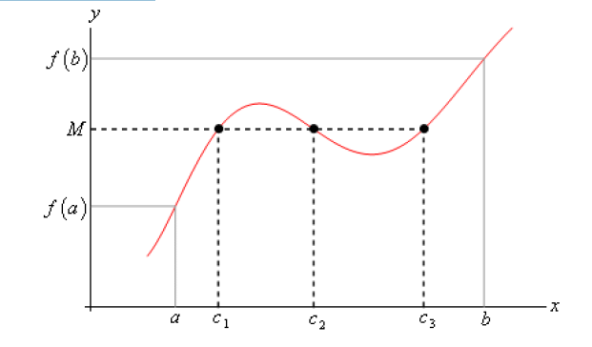

As we can see from this image if we pick any value, *M*, that is between the value of *f(a)* and the

value of *f(b)* and draw a line straight out from this point the line will hit the graph in at least one

point. In other words somewhere between *a* and *b* the function will take on the value of *M*. Also,

as the figure shows the function may take on the value at more than one place.

It’s also important to note that the Intermediate Value Theorem only says that the function will take on the value of *M* somewhere between *a* and *b*. It doesn’t say just what that value will be. It only says that it exists.

So, the Intermediate Value Theorem tells us that a function will take the value of *M* somewhere between *a* and *b* but it doesn’t tell us where it will take the value nor does it tell us how many

times it will take the value.

**A nice application of the Intermediate Value Theorem is to prove the existence of roots of equations.**

**Example :** show that $p\left(x\right)=2x^{3}-5x^{2}-10x+5$ has a root somewhere in the interval [-1,2]

Solution :

Here we are considering whether or not the function will take on the value p(x) =0, somewhere between -1 and 2. In other word we are referring there exist a number c such that -1< c < 2 and p© = 0. Let we define M = 0 and it is the fact that M is

Between p(-1) and p(2) (i.e p(-1) < 0 < p(2) or p(2) < 0 < p(-1) )

Since p(-1) = 8 and p(2) = -19

So we have,

-19 = p(2) < 0 < p(-1) = 8

**Therefore** , *M* = 0 is between *p* (−1) and *p* (2) and since *p* ( *x*) is a polynomial it’s continuous everywhere and so in particular it’s continuous on the interval [-1,2]. By IVT, there must be a number −1< *c* < 2 so that, *p* (*c*) = 0.

Therefore the polynomial does have a root between -1 and 2.

